Superstore Sales Dataset

DEPI Graduation Project

Data analysis Track
R3-Data Analyst Specialist CAI3_DAT1_G2
By:
Ahmed Metwally Ahmed Sharawy
May Mahmoud Samy Abdelmeguid
Nada Hany Mohamed Zaky

Under supervision of
Eng. Ahmed Samir

Project Overview:
The Superstore Sales Analysis project involves the exploration and analysis of a sales dataset containing key transactional and customer information. The dataset includes details such as order ID, order date, shipping mode, customer and product identifiers, sales figures, and categorical breakdowns by product type and geographic region. The primary aim of this project is to generate actionable insights that can support data-driven decision-making in areas such as sales performance, customer behavior, and regional trends.

Background:
Retail businesses generate vast amounts of transactional data that, when analyzed effectively, can uncover trends, inefficiencies, and growth opportunities. The Superstore Sales dataset simulates a mid-sized retail company’s historical sales data, capturing orders made by customers across various product categories and regions. Each entry records critical information, including order timelines, shipping methods, and sales values. This dataset provides a foundation for exploring key business metrics and evaluating the effectiveness of sales strategies, customer reach, and operational logistics.

Objective:
The primary objectives of this project are to:
1. Analyze Sales Performance: Evaluate overall and segmented sales trends across categories, sub-categories, regions, and time periods.
2. Identify High-Value Customers and Products: Determine the most profitable customer segments and best-selling product categories.
3. Assess Shipping and Operational Efficiency: Explore the impact of different shipping modes on delivery timelines and sales outcomes.
4. Uncover Regional Insights: Compare sales distribution and customer behavior across different regions.
5. Support Strategic Planning: Provide data-driven recommendations to enhance sales strategies, inventory management, and customer targeting.

Tools used:
(EXCEL, SQL, Python (Exploratory Data Analysis “EDA”, Normalization, CLEANING, tableau & power BI for visualization)

ملاحظات حول معالجة البيانات
(Data Cleaning Notes)
الجدول: الطلبات (Orders)
الملاحظة:
يحتوي الجدول على عمودين خاصين بالتواريخ، وهما:
- Order Date
- Ship Date
لوحظ أن تنسيق التواريخ في كلا العمودين غير موحد، حيث تظهر القيم بعدة صيغ مختلفة مثل:
- اليوم/الشهر/السنة (DD/MM/YYYY)
- الشهر/اليوم/السنة (MM/DD/YYYY)
- اليوم/الشهر/السنة مع إضافة صفر قبل الشهر (DD/0M/YYYY)
الأثر:
عدم توحيد صيغة التاريخ يؤدي إلى:
- صعوبة في إجراء التحليل الزمني أو ترتيب الطلبات.
- أخطاء في المقارنة بين التواريخ (مثل حساب مدة الشحن).
- مشاكل في استيراد البيانات أو الربط بينها في برامج التحليل مثل Excel أو Power BI أو SQL.
الإجراء (Action)
- توحيد صيغة التاريخ في كلا العمودين إلى تنسيق واحد موحد مثل: YYYY-MM-DD أو DD/MM/YYYY حسب سياسة قاعدة البيانات.
- التأكد من أن نوع البيانات في العمودين هو Date وليس Text.
- التحقق من صحة التواريخ غير المنطقية (مثل تواريخ الشحن قبل تاريخ الطلب).

1.5 building data modeling
. جدول المنتجات (Products)
- يحتوي على تفاصيل كل منتج
Primary Key: Product ID
اسم العمود | الوصف
Product ID | رقم المنتج (معامل ربط أساسي)
Product Name | اسم المنتج
Sub-Category | الفئة الفرعية
Category | الفئة الرئيسية
2.جدول المستهلكين (Customers)
- يحتوي على بيانات العملاء
Primary Key: Customer ID
اسم العمود | الوصف
Customer ID | رقم العميل (معامل ربط أساسي)
Customer Name | اسم العميل
Segment | نوع العميل (Consumer, Corporate, Home Office)
Country | الدولة
City | المدينة
State | الولاية
Postal Code | الرمز البريدي
Region | الإقليم
3. جدول الطلبات (Orders)
- يحتوي على بيانات الطلبات
Primary Key: Order ID
Foreign Key: Customer ID (Customers يربط بجدول)

اسم العمود | الوصف
Order ID | رقم الطلب (معامل ربط أساسي)
Order Date | تاريخ الطلب
Ship Date | تاريخ الشحن
Ship Mode | طريقة الشحن (Standard, Second, First, Same Day)
Customer ID | معامل ثانوي Foreign يربط بجدول المستهلكين
4. جدول المبيعات (Sales)
- يحتوي على تفاصيل المبيعات ويربط بين الطلبات والمنتجات
Primary Key: (Order ID + Product ID) أو Row ID
Foreign Keys:
- Order ID (Orders يربط بجدول)
- Product ID (Products يربط بجدول)
اسم العمود | الوصف
Row ID | رقم الصف (معامل ربط أساسي للملاحظة وللتأكد من عدم وجود تكرارات)
Order ID | معامل ثانوي Foreign يربط بجدول الطلبات
Product ID | معامل ثانوي Foreign يربط بجدول المنتجات
Sales | قيمة المبيعات
- العلاقات بين الجداول:
- العلاقة بين المستهلكين (Customers) و الطلبات (Orders) هي علاقة One-to-Many من خلال العمود Customer ID
- العلاقة بين الطلبات (Orders) والمنتجات (Products) هي علاقة Many-to-Many يتم تحقيقها من خلال جدول المبيعات (Sales) الذي يعمل كـ جدول وسيط
- العلاقة بين الطلبات (Orders) و المبيعات (Sales) هي علاقة One-to-Many من خلال العمود Order ID
- العلاقة بين المنتجات (Products) و المبيعات (Sales) هي علاقة One-to-Many من خلال العمود Product ID

Tool 1: Microsoft Excel
Data Preparation and Analysis Workflow
1. Data Unification
- Objective: Ensure consistency and integrity across product-related data.
- Process:
  - Standardized and unified Product IDs for each corresponding Product Name to maintain consistent identification across datasets.
  - Resolved discrepancies and ensured all products were correctly mapped to their respective IDs.
2. Data Normalization
- Objective: Eliminate data redundancy and improve database efficiency.
- Process:
  - Applied First Normal Form (1NF) by removing repeating groups and ensuring each column contains atomic values.
  - Applied Second Normal Form (2NF) by removing partial dependencies—each non-key attribute depends on the whole primary key.
  - Applied Third Normal Form (3NF) by removing transitive dependencies—ensuring non-key attributes depend only on the primary key.
  - Result: The large, unstructured table was decomposed into four related tables:
    - Products
    - Customers
    - Orders
    - Sales
3. Data Cleaning
- Objective: Ensure data accuracy and consistency before modeling.
- Process:
  - Used Power Query to identify and remove duplicate records from each table.
  - Validated data integrity and verified uniqueness of key fields.
4. Data Modeling
- Objective: Establish logical relationships for analysis.
- Process:
  - Defined Primary Keys (unique identifiers) for each table.
  - Created Foreign Key relationships between tables (e.g., linking Orders to Customers and Products).
  - Built a relational data model to enable efficient querying and reporting.
5. Data Analysis and Visualization
- Objective: Derive business insights from the prepared data.
- Process:
  - Utilized Pivot Tables in Excel to analyze sales performance, customer behavior, and product trends.
  - Developed interactive summaries and key performance metrics to support decision-making.

Total Sales: 2.261.536
Products No.: 1818
Orders No: 4922
Customers No.:794

Tool 2 SQL
Creating Database:
- Database was created named “SuperStoreSales”
- Then 4 tables were created (Customer -Product- Order- Details) with their columns and Data type in each column
Inserting The data:
- We tried Microsoft Access at first, but it didn’t work
- So instead, we saved each sheet in the workbook as .CSV file so we were left by 4 .CSV files one for each table because it can’t save the whole workbook at a time
- Then we used Bulk insert to insert all the data.
Data Cleaning:
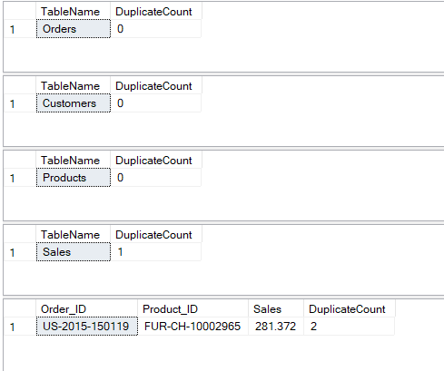
- We checked the data for duplicates; All tables were duplicates free except for Sales table one duplicate was found of Order_ID “US-2015-150119” and Product_ID “FUR-CH-10002965”
- So, we dropped that duplicate using the syntax Delete and now our data is Duplicates-Free.
- We checked our Data for Nulls, and no Nulls were found.
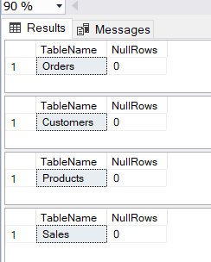
- Then, we were Trying To unify the format of the Order Date and Ship date and there were two problems. First, Dates are written by more Than one format. Second, After saving Our files as .CSV , It changed all the data as a text so SQL is reading it right now as a text and Not a date and If we changed the Data type to Date it will give as inaccurate data full of Nulls because Dates are written by more than one format besides SQL only reads the ISO 8601 format YYYY-MM-DD.
- So, we approached by Unifying the text format, then splitting The Text into Day, Month and Year columns, then adding a customized column that calculate the date by merging the three other columns of Day, Month and Year and we did so for both Order Date and Ship Date.
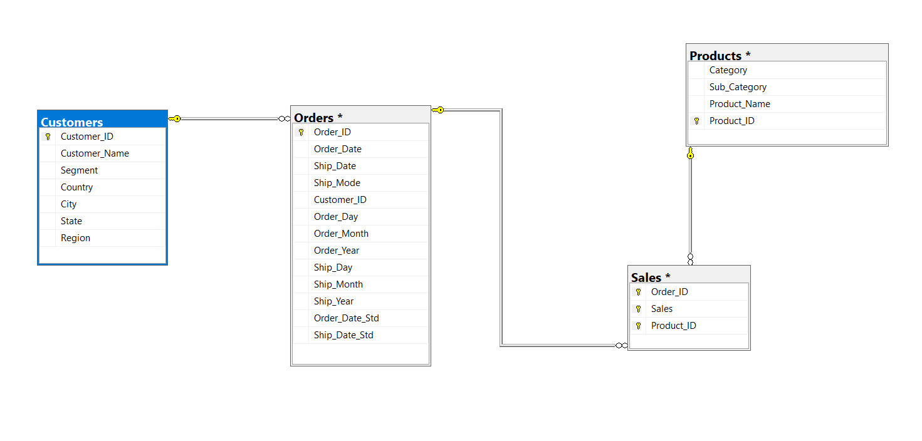
Creating Relationship between Tables:
- We created the relationship between the 4 tables by using the relationship diagram as shown:
-In Customers table Customer_ID is the primary key.
-In Orders table Order_ID is the primary key and Customer_ID is the foreign key.
-In Products table Product_ID is the primary key.
-In Sales table Order_ID,Product_ID and Sales are the Primary Key (Composite Key).


Tool 3: Python
- Importing the Required Libraries
We start by importing the necessary Python libraries for data manipulation and analysis (Pandas-Numpy-sys-…).
- We imported our dataset and extracted each sheet from the workbook
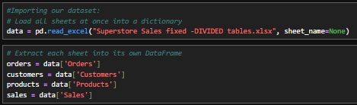

- Then, we started our cleaning:
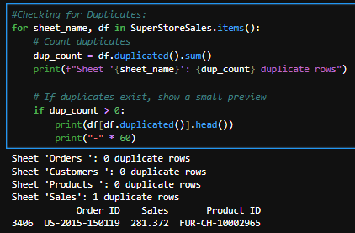
- First, we checked our Data for duplicates only one duplicate was found in our data in the sales table it was order with Order ID: US-2015-150119 and Product ID FUR-CH-10002965.

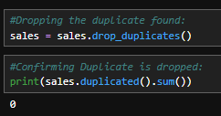
- Then, we dropped that duplicate, and we verified that our data is duplicate-free.

- Then We checked our data for Nulls, and no Nulls were found.
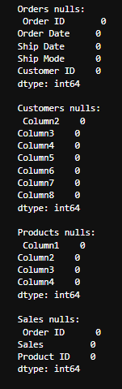

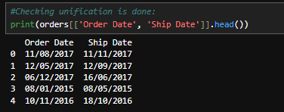
- Then, we started the unification of the dates format in the Ship Date and Order Date columns.

- Then we started Creating Relationship between Tables:
- We created the relationship between the 4 tables by using the relationship diagram as shown:
-In Customers table Customer_ID is the primary key.
-In Orders table Order_ID is the primary key and Customer_ID is the foreign key.
-In Products table Product_ID is the primary key.
-In Sales table Order_ID,Product_ID and Sales are the Primary Key (Composite Key).
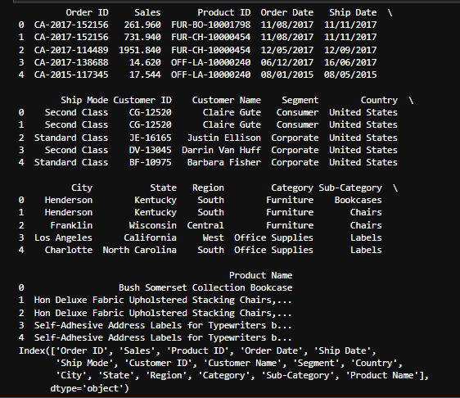

Then we Started our analysis…

Question analysis:
Customer analysis:
1. Who are the top 10 customers in terms of total revenue?
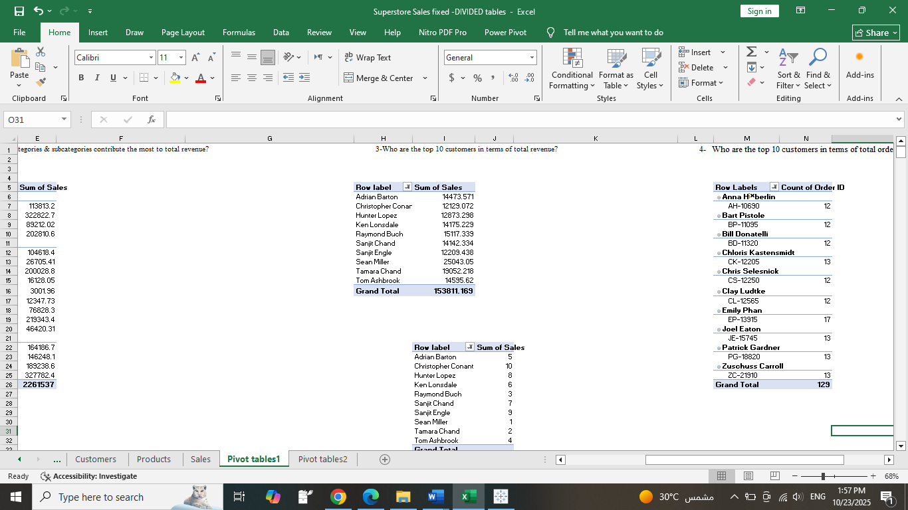

2. Who are the top 10 customers in terms of total orders?
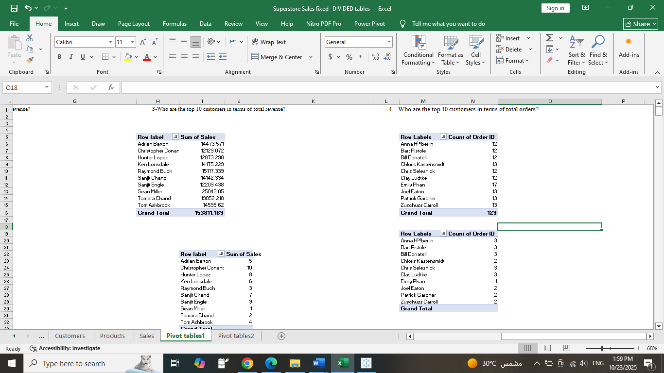

3. How do customer segments differ in purchase frequency and order size?
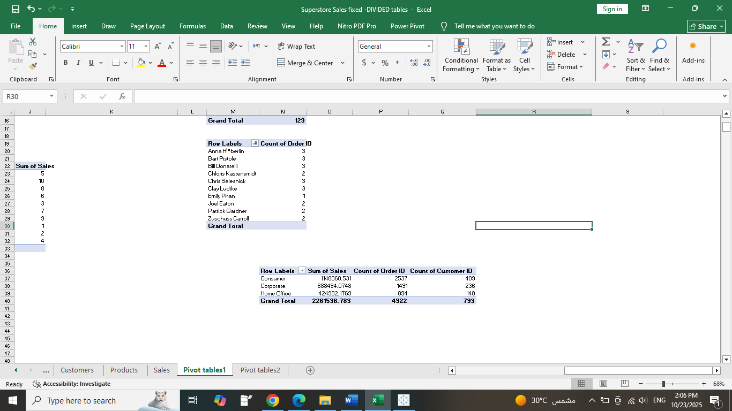

4. Which customer segment (Consumer, Corporate, Home Office) generates the highest revenue?
5. Which regions or cities have the most profitable customers?
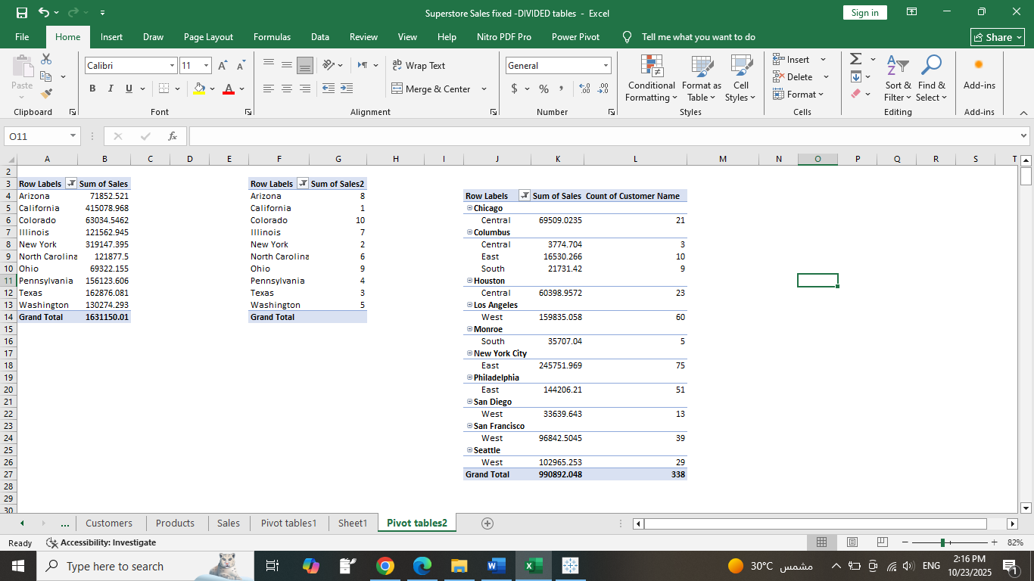
6. Which regions have the highest average sales per customer?
Row Labels | Sum of Sales | Average of Sales2 | Count of Customer Name
Central
Illinois | 121562.9445 | 210.681013 | 40
Indiana | 14592.05 | 131.4599099 | 9
Iowa | 12426.147 | 276.1366 | 3
Kansas | 748.026 | 74.8026 | 1
Michigan | 51484.1078 | 264.0210656 | 15
Minnesota | 49373.4885 | 280.5311847 | 13
Missouri | 12155.505 | 221.0091818 | 6
Nebraska | 7548.8 | 160.612766 | 3
Oklahoma | 5135.818 | 320.988625 | 3
South Dakota | 2339.598 | 146.224875 | 1
Texas | 162876.0813 | 187.645255 | 72
Wisconsin | 43398.718 | 279.991729 | 9
East
Connecticut | 18810.377 | 238.106038 | 7
Delaware | 21056.085 | 226.4095161 | 6
District of Columbia | 2355.21 | 123.9584211 | 2
Maryland | 1588.81 | 66.20041667 | 4
Massachusetts | 22886.746 | 263.066046 | 8
New Hampshire | 12590.196 | 267.8765106 | 3
New Jersey | 24531.942 | 199.4466829 | 9
New York | 319147.3945 | 263.9763395 | 95
Ohio | 69322.155 | 149.0799032 | 38
Pennsylvania | 156123.606 | 225.9386483 | 55
Rhode Island | 18501.411 | 222.9085663 | 6
South
Alabama | 23210.1668 | 263.7518955 | 7
Arkansas | 16405.884 | 546.8628 | 3
Florida | 47645.9458 | 188.3238964 | 22
Georgia | 50716.649 | 269.7694096 | 17
Kentucky | 20876.587 | 181.5355391 | 12
Louisiana | 16625.868 | 195.5984471 | 6
Mississippi | 11024.419 | 234.5621064 | 4
North Carolina | 121877.5001 | 335.750689 | 32
Tennessee | 25180.0952 | 189.3240241 | 11
Virginia | 53082.863 | 234.8799248 | 18
West
Arizona | 71852.521 | 265.1384539 | 20
California | 415078.9677 | 219.7347632 | 157
Colorado | 63034.5462 | 208.0348059 | 23
Nevada | 1214.986 | 101.2488333 | 2
New Mexico | 6046.188 | 147.468 | 4
Oregon | 14068.8055 | 281.37611 | 3
Utah | 22765.281 | 237.1383438 | 7
Washington | 130274.2928 | 310.9171666 | 37
Grand Total | 2261536.783 | 230.7690595 | 793

7. Which cities have the highest customer retention or loyalty trends (by order frequency)?
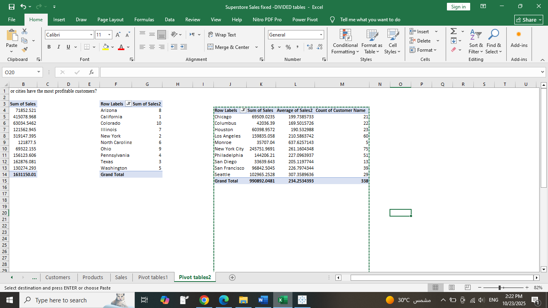

8. What is the total number of customers filtered by each region & city?

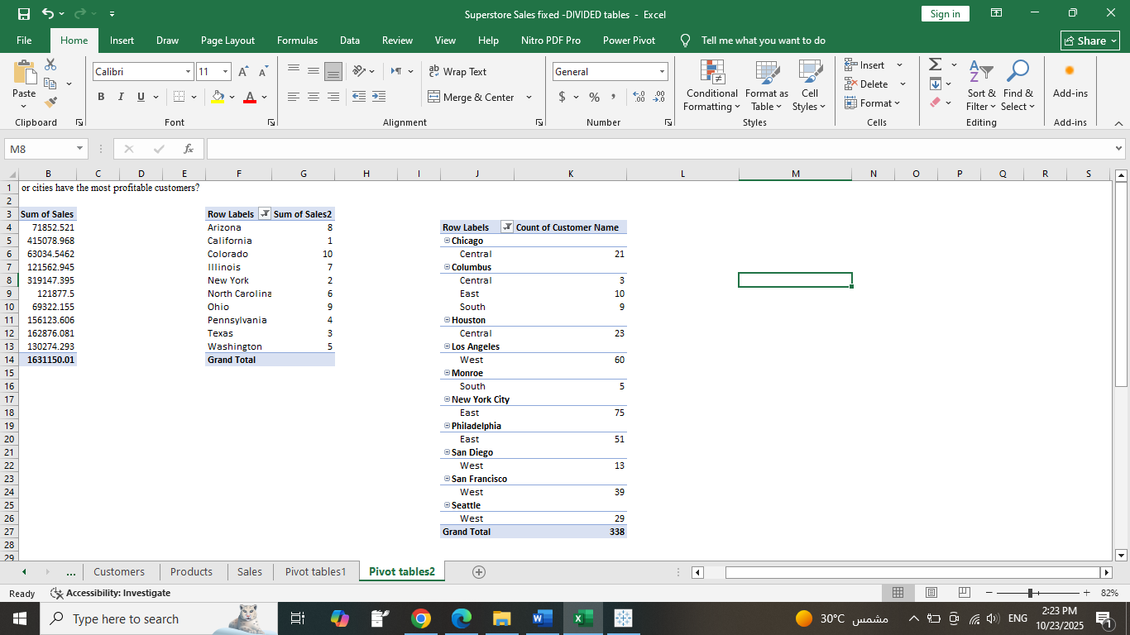

9. How many customers in each state?
Row Labels | Count of Customer Name
Alabama | 7
Arizona | 20
Arkansas | 3
California | 157
Colorado | 23
Connecticut | 7
Delaware | 6
District of Columbia | 2
Florida | 22
Georgia | 17
Illinois | 40
Indiana | 9
Iowa | 3
Kansas | 1
Kentucky | 12
Louisiana | 6
Maryland | 4
Massachusetts | 8
Michigan | 15
Minnesota | 13
Mississippi | 4
Missouri | 6
Nebraska | 3
Nevada | 2
New Hampshire | 3
New Jersey | 9
New Mexico | 4
New York | 95
North Carolina | 32
Ohio | 38
Oklahoma | 3
Oregon | 3
Pennsylvania | 55
Rhode Island | 6
South Dakota | 1
Tennessee | 11
Texas | 72
Utah | 7
Virginia | 18
Washington | 37
Wisconsin | 9
Grand Total | 793

10. What customer segments are most profitable (e.g., by region,)?
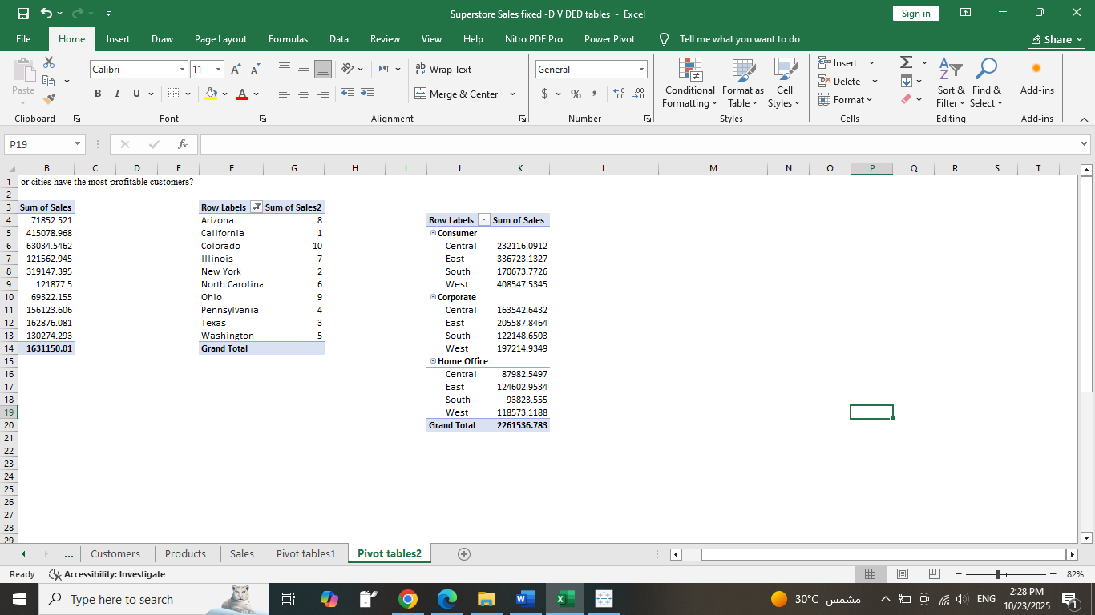
Products analysis:
1- What are the top 10 best-selling products?
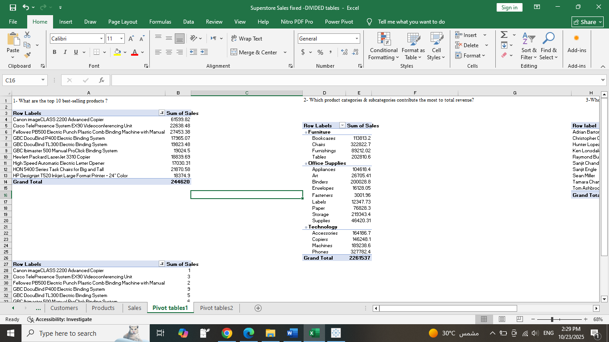
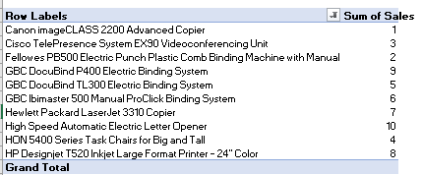
2- Which product categories contribute the most to total revenue?
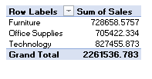

3- Which product categories and sub-categories generate the highest sales?
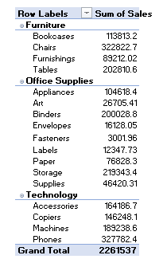

4- How does product performance vary across regions and customer segments?
Row Labels | Sum of Sales
Consumer
Furniture
Central | 80695.2882
East | 101925.0427
South | 52789.5926
West | 152286.3345
Office Supplies
Central | 85242.371
East | 92003.952
South | 56819.641
West | 125286.644
Technology
Central | 66178.432
East | 142794.138
South | 61064.539
West | 130974.556
Corporate
Furniture
Central | 54132.1032
East | 68881.0954
South | 30605.0723
West | 66703.4309
Office Supplies
Central | 46829.967
East | 66839.655
South | 44419.372
West | 66041.542
Technology
Central | 62580.573
East | 69867.096
South | 47124.206
West | 64469.962
Home Office
Furniture
Central | 24786.3327
East | 24966.0094
South | 28144.16
West | 42744.1138
Office Supplies
Central | 30526.78
East | 41011.243
South | 15131.892
West | 35269.275
Technology
Central | 32669.437
East | 58625.701
South | 50547.503
West | 40559.73
Grand Total | 2261536.783

5-How can we visualize the contribution of each sub-category to overall revenue?
Row Labels | Sum of Sales | Sum of Sales2
Furniture
Bookcases | 113813.1987 | 5.03%
Chairs | 322822.731 | 14.27%
Furnishings | 89212.018 | 3.94%
Tables | 202810.628 | 8.97%
Office Supplies
Appliances | 104618.403 | 4.63%
Art | 26705.41 | 1.18%
Binders | 200028.785 | 8.84%
Envelopes | 16128.046 | 0.71%
Fasteners | 3001.96 | 0.13%
Labels | 12347.726 | 0.55%
Paper | 76828.304 | 3.40%
Storage | 219343.392 | 9.70%
Supplies | 46420.308 | 2.05%
Technology
Accessories | 164186.7 | 7.26%
Copiers | 146248.094 | 6.47%
Machines | 189238.631 | 8.37%
Phones | 327782.448 | 14.49%
Grand Total | 2261536.783 | 100.00%

6-What are the highest revenue products per Customer segment?
Row Labels | Sum of Sales | %of total sales
Canon imageCLASS 2200 Advanced Copier
Consumer | 32899.906 | 13.45%
Corporate | 17499.95 | 7.15%
Home Office | 11199.968 | 4.58%
Cisco TelePresence System EX90 Videoconferencing Unit
Home Office | 22638.48 | 9.25%
Fellowes PB500 Electric Punch Plastic Comb Binding Machine with Manual Bind
Consumer | 14489.286 | 5.92%
Corporate | 7117.544 | 2.91%
Home Office | 5846.554 | 2.39%
GBC DocuBind P400 Electric Binding System
Consumer | 11976.712 | 4.90%
Home Office | 5988.356 | 2.45%
GBC DocuBind TL300 Electric Binding System
Consumer | 13096.054 | 5.35%
Corporate | 6727.425 | 2.75%
GBC Ibimaster 500 Manual ProClick Binding System
Consumer | 17122.05 | 7.00%
Corporate | 760.98 | 0.31%
Home Office | 1141.47 | 0.47%
Hewlett Packard LaserJet 3310 Copier
Consumer | 4199.93 | 1.72%
Corporate | 5399.91 | 2.21%
Home Office | 9239.846 | 3.78%
High Speed Automatic Electric Letter Opener
Consumer | 12117.722 | 4.95%
Corporate | 4912.59 | 2.01%
HON 5400 Series Task Chairs for Big and Tall
Consumer | 17384.304 | 7.11%
Corporate | 3504.9 | 1.43%
Home Office | 981.372 | 0.40%
HP Designjet T520 Inkjet Large Format Printer - 24" Color
Consumer | 18374.895 | 7.51%
Grand Total | 244620.204 | 100.00%

Orders & Sales analysis:
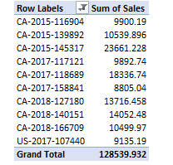
1- What are the top 10 orders according to sales?

2-What is the distribution of orders that are mostly purchased by region?
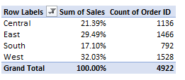

3-Does Ship Mode affect total sales?
4-Which shipping modes are most used and most profitable?
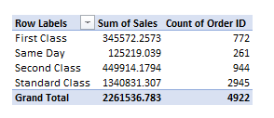

Customer analysis:
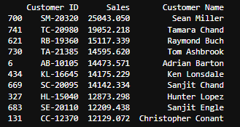
1. Who are the top 10 customers in terms of total revenue?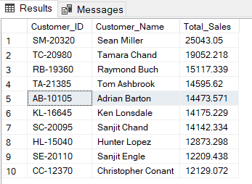
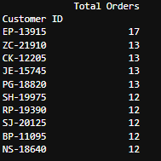
2. Who are the top 10 customers in terms of total orders?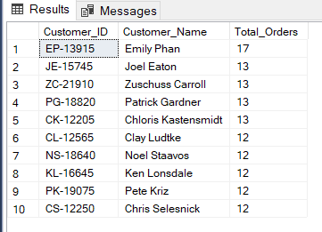
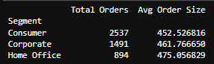
3. How do customer segments differ in purchase frequency and order size?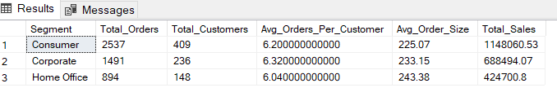
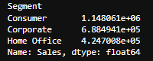
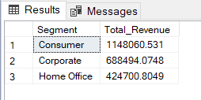
4. Which customer segment (Consumer, Corporate, Home Office) generates the highest revenue?
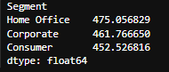
5. What’s the average order value for each customer’s segment?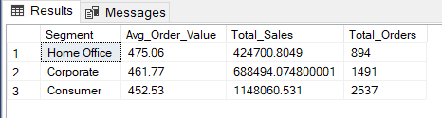
6. Which regions or cities have the most profitable customers?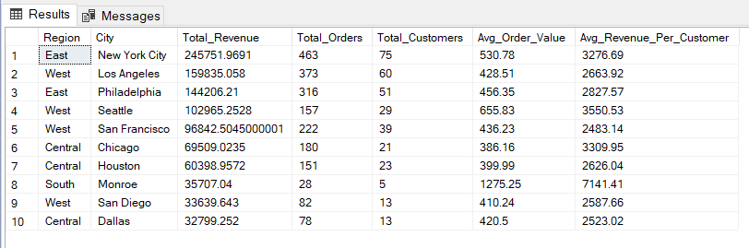
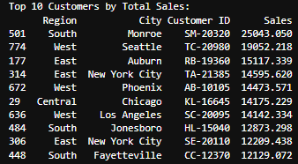
7. What’s the average order frequency per customer per year?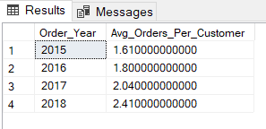
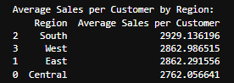
8. Which regions have the highest average sales per customer?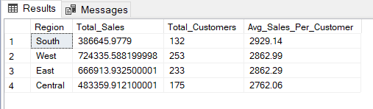
9. What is the repeated purchase per segment or region? 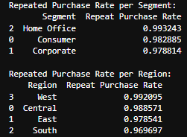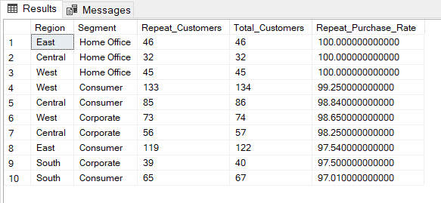
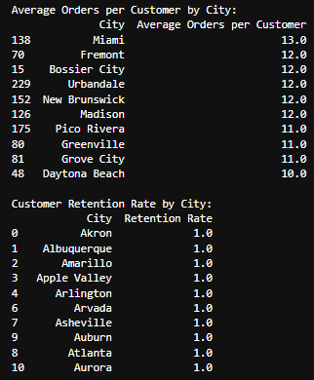
10. Which cities have the highest customer retention or loyalty trends (by order frequency)?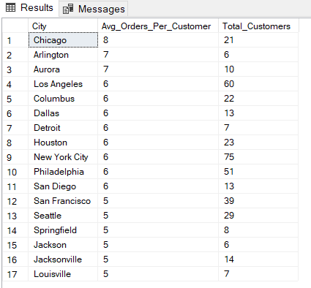
11. What is the total number of customers filtered by each region?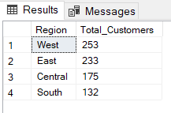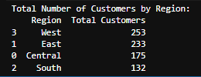

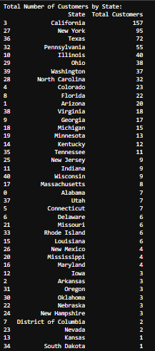
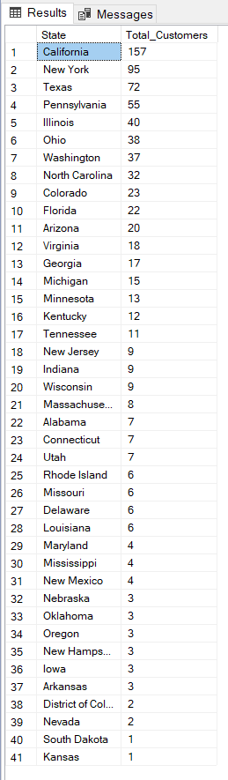
12. How many customers in each state?

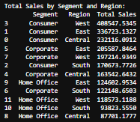
13. What customer segments are most profitable (e.g., by region,)?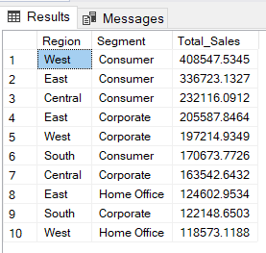

Products analysis:
1- What are the top 10 best-selling products and the bottom 10 least-selling products?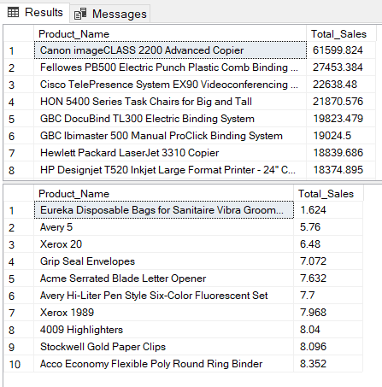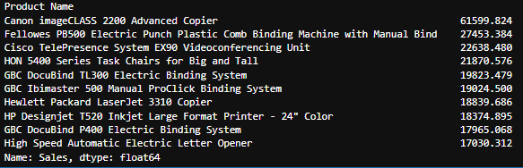
2- Which product categories contribute the most to total revenue?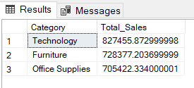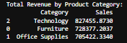
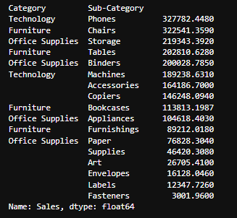
3- Which product categories and sub-categories generate the highest sales?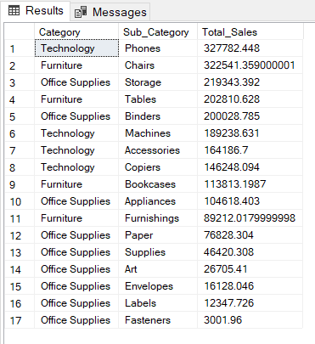
4- How does product performance vary across regions and customer segments?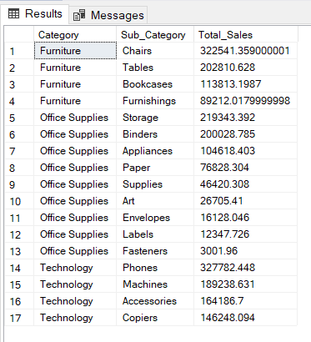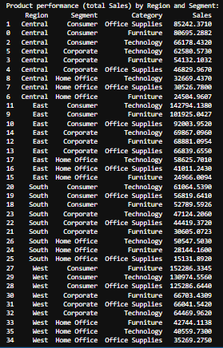
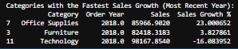
5-Which product categories show the fastest sales growth over time?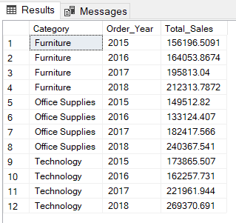
6-How can we visualize the contribution of each sub-category to overall revenue?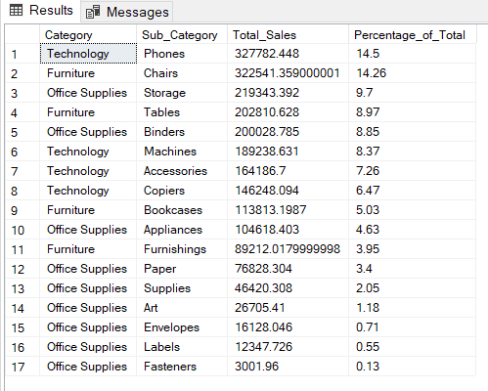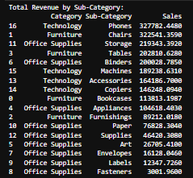
7-What are the most frequently ordered products per region or customer segment?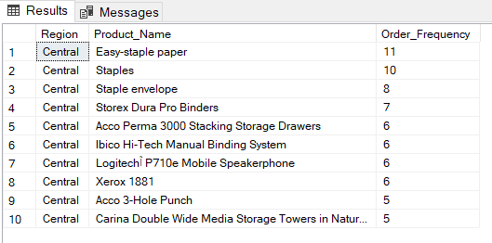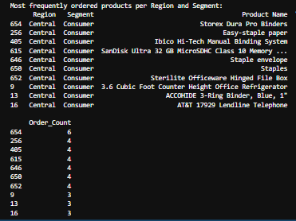

Orders & Sales analysis:
1- What are the total sales and average sales per order?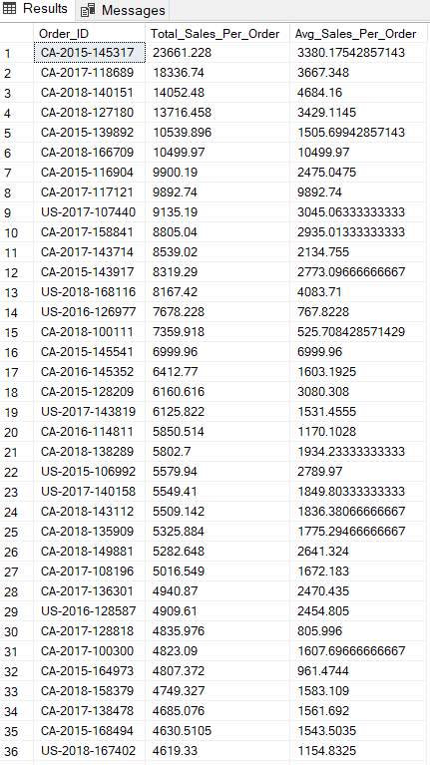

2-How many orders have been placed every year?
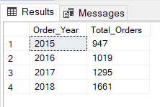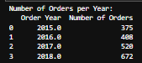
3-What is the distribution of orders that are mostly purchased by region?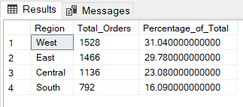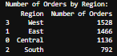
4-What is the average shipping time (difference between Order Date & Ship Date)?
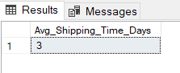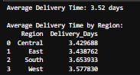
5-What’s the average order frequency per customer per year?
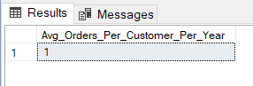
6- What is the total sales revenue over time (quarterly or annually)?
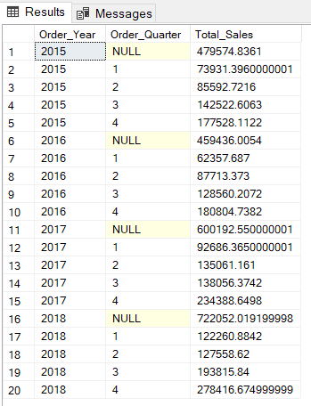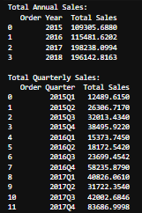
7-Does Ship Mode affect total sales or delivery speed?
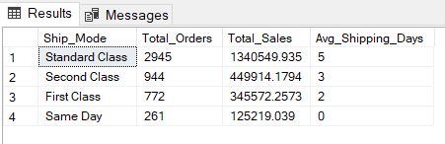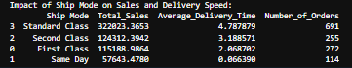
8-Which shipping modes are most used and most profitable?
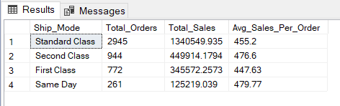
9-How do sales fluctuate over time (monthly, quarterly, yearly)?
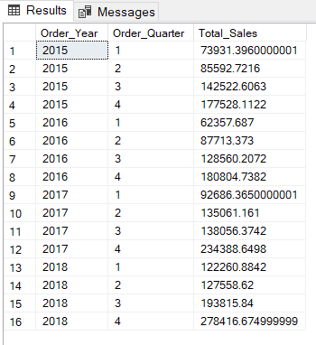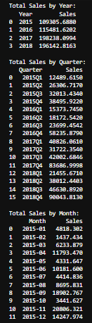
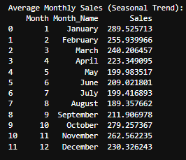
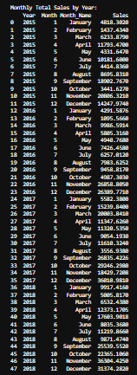
10-Are there any seasonal patterns (e.g., sales peaks around holidays)?
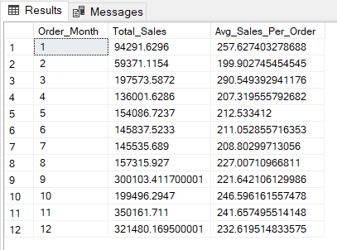

Analysis Questions bank
Customer analysis:
1. Who are the top 10 customers in terms of total revenue?
2. Who are the top 10 customers in terms of total orders?
3. How do customer segments differ in purchase frequency and order size?
4. Which customer segment (Consumer, Corporate, Home Office) generates the highest revenue?
5. What’s the average order value for each customer segment?
6. Which regions or cities have the most profitable customers?
7. What’s the average order frequency per customer per year?
8. Which regions have the highest average sales per customer?
9. What is the repeated purchase per segment or region?
10. Which cities have the highest customer retention or loyalty trends (by order frequency)?
11. What is the total number of customers filtered by each regions?
12. How many customers in each state?
13. What customer segments are most profitable (e.g., by region,)?

Products analysis:
1- What are the top 10 best-selling products?
2- Which product categories contribute the most to total revenue?
3- Which product categories and sub-categories generate the highest sales ?
4- How does product performance vary across regions and customer segments?
5-Which product categories show the fastest sales growth over time?
6-How can we visualize the contribution of each sub-category to overall revenue?
7-What are the most frequently ordered products per region or customer segment?

Orders & Sales analysis:
1- What are the total sales and average sales per order?
2-How many orders have been placed in every year?
3-What is the distribution of orders that mostly purchased by region?
4-What is the average shipping time (difference between Order Date & Ship Date)?
5-What’s the average order frequency per customer per year?
6- What is the total sales revenue over time (quarterly or annually)?
7-Does Ship Mode affect total sales or delivery speed?
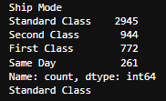
8-Which shipping modes are most used and most profitable?
9-How do sales fluctuate over time (monthly, quarterly, yearly)?
10-Are there any seasonal patterns (e.g., sales peaks around holidays)?
Top 10 sales state:
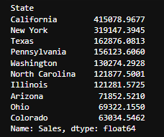

Visualization using Tableau:
Total Sales: 2.261.536
Products No.: 1817
Orders No: 4922
Customers No.:793

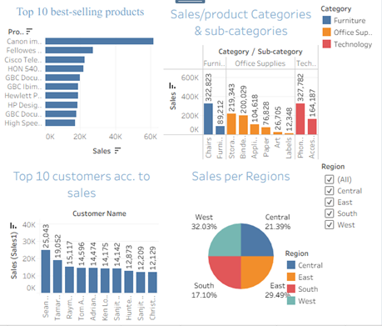

1- What are the top 10 best-selling products?
Customer analysis:
1. Who are the top 10 customers in terms of total revenue?
3- Which product categories and sub-categories generate the highest sales?
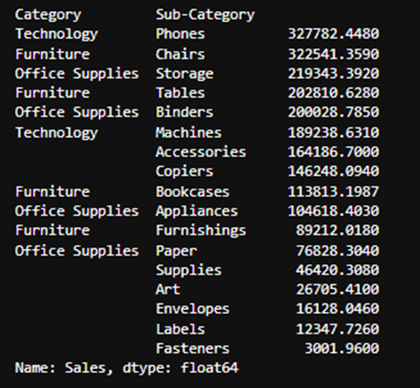

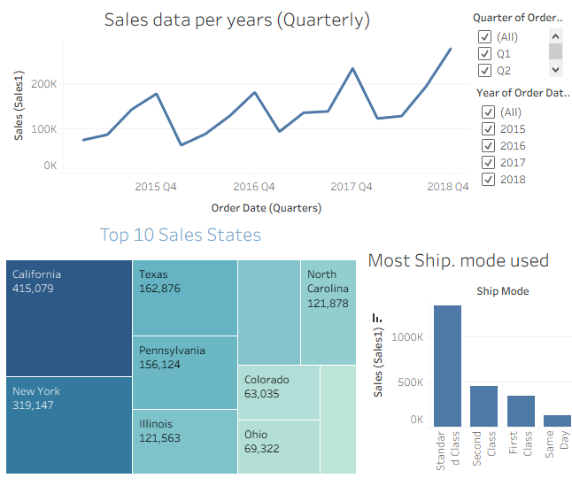

Most shipment mode used
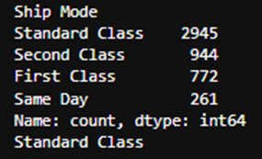

Top 10 Sales states

Row Labels | Sum of Sales2
Arizona | 8
California | 1
Colorado | 10
Illinois | 7
New York | 2
North Carolina | 6
Ohio | 9
Pennsylvania | 4
Texas | 3
Washington | 5
Grand Total
Row Labels | Sum of Sales2
Arizona | 71852.521
California | 415078.9677
Colorado | 63034.5462
Illinois | 121562.9445
New York | 319147.3945
North Carolina | 121877.5001
Ohio | 69322.155
Pennsylvania | 156123.606
Texas | 162876.0813
Washington | 130274.2928
Grand Total | 1631150.009

